

Uncollected Children Policy

TreeHouse Education endeavours to ensure that all children are collected by a parent or carer at the end of each session. If a child is not collected, and the parent or carer has not notified us that they will be delayed, we will follow the procedure set out below:

Up to 20 minutes late
- When the parent or carer arrives they will be reminded that they must call the emergency number to notify us if they are delayed.
- The parent or carer will be informed that penalty fees will have to be charged (unless the delay was genuinely unavoidable).
- A charge will be £10.00 per child every 20 minutes (or part thereof) after the booked session has ended. The fee will need to be paid in full before the child attends the next session.

Over 20 minutes late
- If a parent or carer is more than 20 minutes late in collecting their child, the manager will try to contact them using the contact details on file.
- If there is no response from the parent or carer, messages will be left requesting that they contact the manager immediately. The manager will then try to contact the emergency contacts listed on the child’s registration form.
- While waiting to be collected, the child will be supervised by TreeHouse staff.
- When the parent or carer arrives they will be reminded that they must call the TreeHouse to notify us if they are delayed, and that penalty fees will have to be charged (except in exceptional circumstances).

Over 30 minutes late
- The child will remain in the care of the TreeHouse’s staff, on the premises if possible, until collected by the parent or carer, or until placed in the care of the Social Care team.
- If it is not possible for the child to remain at the premises, a note will be left on the door of the location informing the child’s parent or carer where the child has been taken (eg to the home of a staff member or into the care of a safeguarding agency) and leaving a contact number. A further message will be left on the parent or carer’s telephone explaining events.
- If the manager has been unable to contact the child’s parents or carers after 1 hour, the manager will contact the local Social Care team for advice.

Managing persistent lateness
The manager will record incidents of late collection and will discuss them with the child’s parents or carers. Parents and carers will be reminded that if they persistently collect their child late they may lose their place at the TreeHouse.

This policy was adopted by: TreeHouse Education | Date: 1st May 2024
Last reviewed on: 16th July 2025 | Signed: 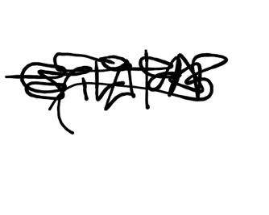
To be reviewed on: December 2025

Written in accordance with the Statutory Framework for the Early Years Foundation Stage (2014): Safeguarding and Welfare Requirements: Information for parents and carers [3.73].

