

Whistleblowing Policy

TreeHouse Education is committed to the highest standards of openness, probity and accountability. If a member of staff discovers evidence of malpractice or wrongdoing within the TreeHouse they can disclose this information internally without fear of reprisal. Our Whistleblowing policy is intended to cover concerns such as:
- Financial malpractice or fraud
- Failure to comply with a legal obligation
- Dangers to health and safety or the environment
- Criminal activity
- Improper conduct or unethical behaviour

This policy should not be used to question business decisions made by TreeHouse, or to raise any matters that are covered under other policies (eg discrimination or racial harassment). Any allegations relating to child protection will follow the procedures set out in the Safeguarding Children policy. Any concerns relating to the employment conditions of an individual member of staff should be raised according to the procedures set out in the Staff Grievance policy.

Raising a concern
Ideally the staff member should put his or her allegations in writing, setting out the background to the situation, giving names, dates and places where possible, and the reason why they are concerned about the situation.

In the first instance concerns should be taken to the manager. If, due to the nature of the problem, this is not possible, consult your local authority play-work advisor on 01296 383485 for advice.

If this person or body is unwilling or unable to act on the concern, the staff member should then raise it with:
- Ofsted (if it concerns the safe and effective running of the club)
- The Local Authority Designated Officer or the Local Safeguarding Children Board (if it concerns a child protection issue and is not already covered by the procedure set out in the Club’s Safeguarding Children policy)
- Ultimately, with the police (if a crime is thought to have been committed).

If the member of staff is still uncertain about how to proceed with the concern, he or she can contact the whistle-blowing charity PCAW (Public Concern at Work) for advice.

Responding to a concern
Initial enquiries will usually involve a meeting with the individual raising the concern, and will decide whether an investigation is appropriate and, if so, what form it should take. If a concern relates to issues which fall within the scope of other policies, it will be addressed under those policies.

If the initial meeting does not resolve the concern, further investigation is required. The appropriate person will investigate the concerns thoroughly, ensuring that a written response can be provided within ten working days where feasible, or if this is not possible, giving a date by which the final response can be expected. The response should include details of how the matter was investigated, conclusions drawn from the investigation, and who to contact if the member of staff is unhappy with the response and wishes to take the matter further.

Rights and responsibilities of the whistle-blower
All concerns will be treated in confidence and TreeHouse will make every effort not to reveal the identity of anyone raising a concern in good faith. At the appropriate time, however, the member of staff may need to come forward as a witness.

If a member of staff raises a concern in good faith which is then not confirmed by the investigation, no action will be taken against that person.

If the investigation concludes that the member of staff maliciously fabricated the allegations, disciplinary action may be taken against that person.

Contact information
LADO (Local Authority Designated Officer): 01296 382070.
LSCB (Local Safeguarding Children Board): 0845 4600001 (Out of hours Duty team – 0800 999 7677)
Ofsted: 0300 123 1231
PCAW (Public Concern at Work): 020 7404 6609 (website: www.pcaw.org.uk)

Related policies
Staff Grievance policy, Safeguarding Children policy.

This policy was adopted by: TreeHouse Education Ltd | Date: 1st May 2024
Last reviewed on: 16th July 2025 | Signed: 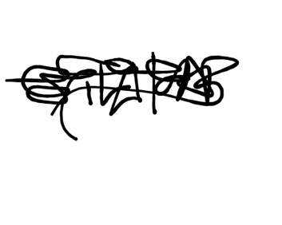
To be reviewed on: December 2025

