

Behaviour Policy

TreeHouse aims to encourage children to adopt the highest standards of behaviour. We believe that children flourish best in a safe environment in which everyone knows what is expected of them and whereby children are free to develop their play and learning without fear of being hurt or hindered by anyone else.
The aims of our Behaviour Policy are to help children to:
• Develop a sense of caring and respect for one another.
• Build caring and co-operative relationships with other children and adults.
• Develop a range of social skills and help children to learn what constitutes acceptable behaviour.
• Develop confidence, self-discipline and self-respect.

Behaviour Management Strategy
TreeHouse staff will manage behaviour according to clear, consistent and positive strategies. Parents and Carers are encouraged to contribute to these. Behaviour management in the Holiday Club will be structured around the following principles:
• Staff and children will adhere to the TreeHouse Code of Conduct. The code of conduct applies equally to all children and staff.
• Positive behaviour will be reinforced with praise and encouragement
• Negative behaviour will be challenged in a calm and assertive manner.
• When dealing with negative behaviour, staff will communicate in a clear, calm and positive manner.
• Staff will make every effort to set a positive example to children by behaving in a friendly manner.
• Staff will work as a team by discussing incidents and concerns and act consistently.
• Staff will, where possible, discuss concerns with parents and carers at the earliest opportunity any incidences of negative behaviour.
• Staff will encourage and facilitate mediation between children to try to resolve conflicts by discussion and negotiation.
• Staff will keep a record of all incidents.
• Activities at the holiday club will be varied, well planned and structured to avoid children becoming bored or distracted.

Dealing with difficult behaviour
When incidences of negative behaviour occur, staff will listen to the child/children involved and hear the reasons for their actions. Staff will explain to the child or children what was negative about their behaviour and the consequences for both themselves and other people.
Staff will make every effort to ensure that children understand what is being said to them and children will have the opportunity to make amends for their actions and will often be allowed to re-join the activity.
Children will be advised that bad behaviour will be logged and parents will be informed. In the event that unacceptable behaviour persists, we reserve the right to suspend or exclude children from the Holiday Club or After School Club. Incident forms will be sent to parents.

This policy was adopted by: TreeHouse Education Ltd | Date: 10th January 2025
Last reviewed on: January 2026 | Signed: 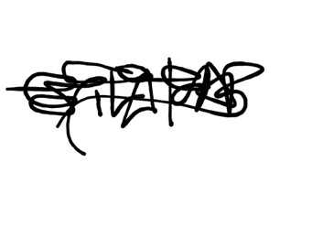
To be reviewed on: July 2026

